**Question 1 - > Write a java program to print 'Hello' on screen and your name on a separate line.**

**// SOURCE CODE**

class Hello {

public static void main(String args[] ){

System.out.println("HELLO ");

System.out.print("MOHIT YADAV");

}

}

OUTPUT :

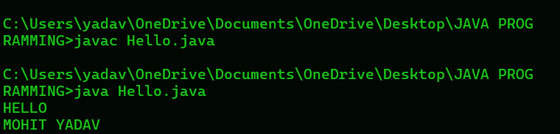

**Question 2 - > Write a java programe to print the sum of two number.**

**// SOURCE CODE**

class Addition{

public static void main(String args [ ] ) {

// declare a variable

int a , b , sum ;

// initialize the variable

a = 74;

b = 36;

// perform the operation

sum = a + b;

System.out.println(sum);

}

}

**OUTPUT :**

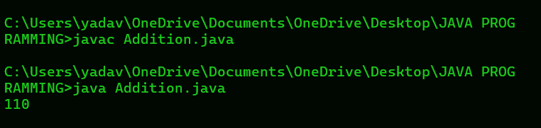

**Question 3 -> Write a java program to divide two numbers and print them on the screen.**

**// SOURCE CODE**

class Divide {

public static void main(String args[]) {

// declare a variable

int a , b , d;

// initialize the variable

a = 50;

b = 3;

// perform the operation

d = a / b;

System.out.println(d);

}

}

**OUTPUT :**

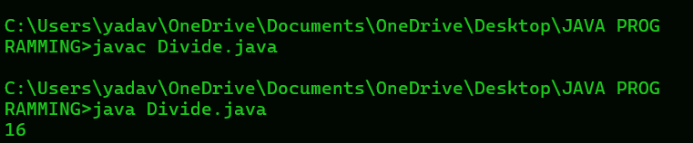

**Question 4 - > Write a java program to print the results of the following operations.**

**// SOURCE CODE**

class Operation {

public static void main(String args[]){

**// BODMAS METHOD LAGEGA TO SOLVING THIS QUESTION**

System.out.println(-5 + 8 * 6);

System.out.println((55 + 9) % 9);

System.out.println(20 + (-3*5)/8);

System.out.println(5 + 15 / 3 * 2 - 8 % 3);

}

}

**OUTPUT :**

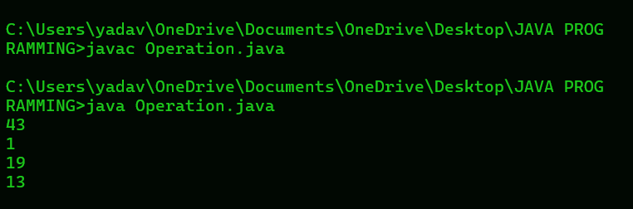

**Question 5 - > Write a java program that takes two number as input and displays the product of two numbers.**

// **SOURCE CODE**

import java.util.Scanner;

class Product {

public static void main(String args[]){

Scanner sc = new Scanner(System.in);

**// declare a variable**

int a , b , p;

**// Take a input**

System.out.print("ENTER A FIRST NUMBER: ");

a = sc.nextInt();

System.out.print("ENTER A SECOND NUMBER: ");

b = sc.nextInt();

**// perform the operation**

p = a * b;

System.out.println(p);

}

}

**OUTPUT:**

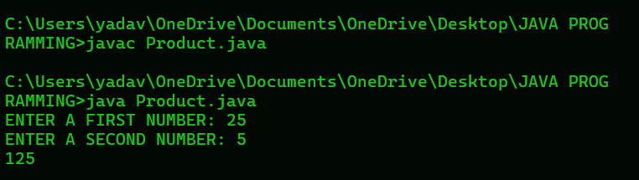

**Question 6 - > Write a java program to print the sum (addition) , multiply , subtract , divide and remainder of two number.**

**// SOURCE CODE**

import java.util.Scanner;

class AllOperation {

public static void main(String args[]){

Scanner sc = new Scanner(System.in);

//**declare a variable**

int a , b;

**// Take a input**

System.out.print("ENTER A FIRST NUMBER: ");

a = sc.nextInt();

System.out.print("ENTER A SECOND NUMBER: ");

b = sc.nextInt();

System.out.println(a + b);

System.out.println(a - b);

System.out.println( a * b);

System.out.println( a / b);

System.out.println( a % b);

}

}

**OUTPUT:**

